noun mix•ol•o•gy \ mik-ˈsä-lə-jē \
the skill of mixing various drinks and ingredients to create cocktails. Masters of mixology spend aeons in cavernous cellars devising new and harmonious creations

Pina Colada
white rum, coconut flavoured rum, pineapple juice, coconut cream 17
Spiced Margarita
tequila, passionfruit, spices 17
Apple & Cinnamon Mojito
white rum, lime, mint, granny smith 17
Aperol Spritz
Aperol, soda, fresh orange, prosecco 15
Whiskey Sour
whiskey, lemon, sugar, egg white 17
Grand Negroni
gin, Campari, sweet vermouth, orange 17
French Martini
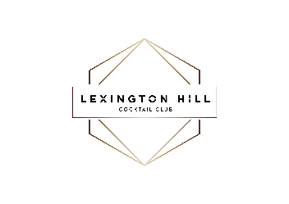
vodka, Chambord, pineapple 17

A new line of Premium Cocktails on tap 15
Margarita & Espresso Martini

noun mix•ol•o•gy \ mik-ˈsä-lə-jē \
the skill of mixing various drinks and ingredients to create cocktails. Masters of mixology spend aeons in cavernous cellars devising new and harmonious creations

Pina Colada
white rum, coconut flavoured rum, pineapple juice, coconut cream 17
Spiced Margarita
tequila, passionfruit, spices 17
Apple & Cinnamon Mojito
white rum, lime, mint, granny smith 17
Aperol Spritz
Aperol, soda, fresh orange, prosecco 15
Whiskey Sour
whiskey, lemon, sugar, egg white 17
Grand Negroni
gin, Campari, sweet vermouth, orange 17
French Martini
vodka, Chambord, pineapple 17

A new line of Premium Cocktails on tap 15
Margarita & Espresso Martini

